**How to Add Your NAB Registry Identification Number**

**to your CAHF Dashboard**

[www.cahf.org/](http://www.cahf.org/)

**Visit CAHF.org**

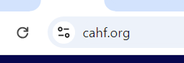

**Click Log in**

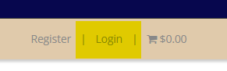

**Enter your Username and Password and click “Login”**

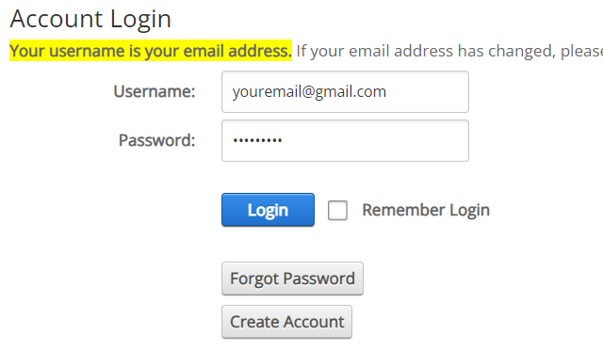

**Click your name to get to your Member Dashboard**



**Once at your Member Dashboard, click “Update My Information” under   
MY ACCOUNT.**

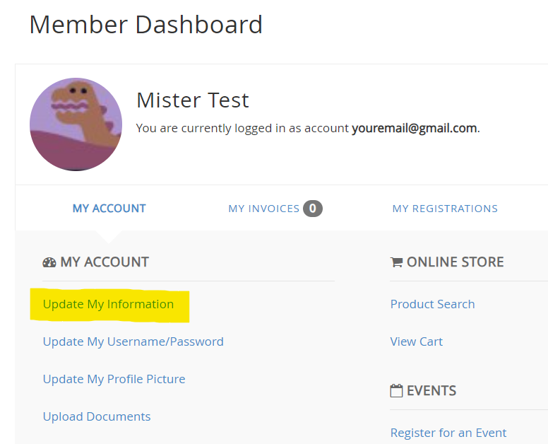

**Under Basic Information, enter your NAB Registry Identification Number in NAB ID# field**

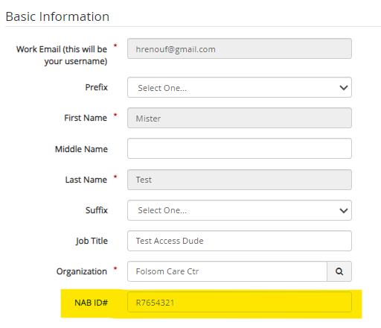

**Scroll to the bottom of the page and click UPDATE PROFILE**

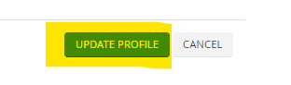

**The below confirmation page will appear, although it does not show this portion of your profile your license number HAS been updated**

